Jira Lab Assignment 8

Harsh Rakeshkumar Bhatt

Project Management, Conestoga College

MGMT8750: Agile Project Management

Professor Shams Salim

July 25, 2023

Screenshot 01
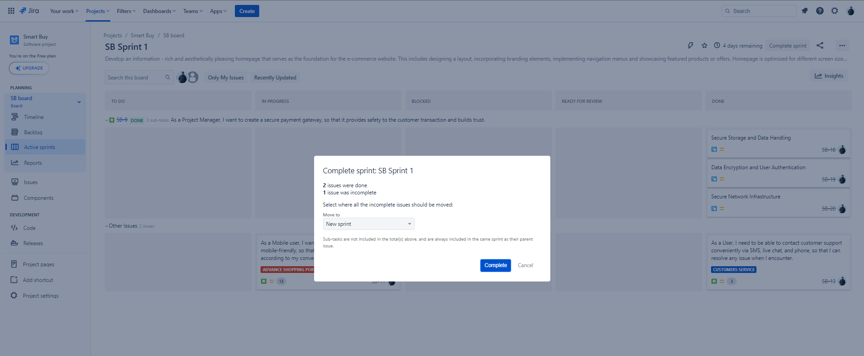

Screenshot 02

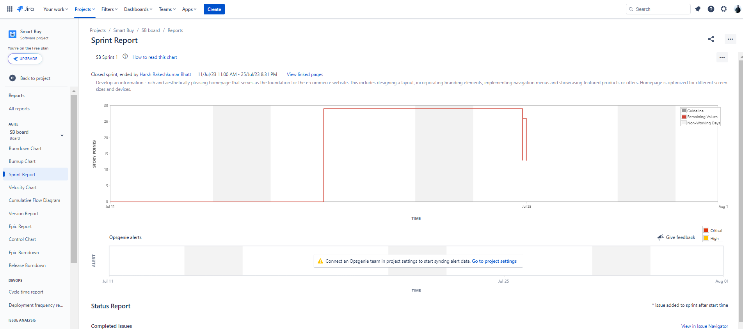

https://hbmgmt8750-agilepm-2023.atlassian.net/jira/software/c/projects/SB/boards/4/reports/sprint-retrospective?sprint=15&atlOrigin=eyJpIjoiMmI4NTAxMDIzZDZkNGQ1Mzk2ZThjY2RiYzE4MzU1ZjUiLCJwIjoiaiJ9

